# **Software Requirements Specification (SRS)**

## **Introduction**

### **1.1 Purpose**

The purpose of this software is to provide nutritious recipes for users.It can provide different recipes for people with different purposes. at the same time, some taboo foods should be avoided, so as to meet the healthy eating needs of all kinds of people.

### **1.2 Intended Audience**

The intended audience is the people who want to eat healthily, specifically, those who want to increase muscle, lose weight or simply for the sake of health through a scientific diet.

### **1.3 Intended Use**

First of all,a user will fill in their personal information (including the user's goals), and then the software analyzes the data according to the information they fill in,selects foods with qualified nutritional indicators such as calories, and provides the user with recipes for a week.

### **1.4 Scope**

The purpose of the software is to help users eat healthily so as to achieve the goal of Increase muscle or lose weight. The software can push some advertisements related to healthy eating, such as fitness equipment and health products to make a profit.

### **1.5 Definitions and Acronyms**

## **2. Overall Description**

### 2.1 User Needs

User can input his/her body information(like height, weight, sex, age, etc.), and target (like losing weight, gainingmuscle, shaping body etc.) to the system.

The system can recommend recipe back to theuser based on the information given by them. This is what user needs.

### **2.2 Assumptions and Dependencies**

The recipe is complete enough to cover allthe dishes that user may need. So that what the user needs can all be found inthe database.

The dishes are ideally cooked so that thecalories of food are same as those in the database. It can make sure that thedata in the database is accurate enough for recommendation.

We do not consider the influence ofuncontrollable variables such as food quality, temperature and humidity etc. onthe calories contained in the food.

## **3.System Features and Requirements**

### **3.1 Functional Requirements**

#### 3.1.1 Increase muscle

When consumers have a need to increase muscle, the software will recommend a high-protein diet based on the consumer's body data.

Input includes gender, height, weight, age, body fat percentage and target body fat percentage. After testing the validity of the input, the recommendation system calculates the calorie requirement and gives a suitable diet based on multiple factors such as the difference between the target body fat rate and the existing body fat rate, gender, and age.

#### 3.1.2 lose weight

When consumers have the need to lose weight, the software will recommend a low-fat, high-fiber diet based on the consumer's body data.

Inputs include gender, height, weight, age, body fat percentage, and target weight. After checking the validity of the input, the recommendation system calculates the calorie requirement based on multiple factors such as the difference between the target weight and the existing weight, gender, and age, and gives a suitable diet.

#### 3.1.3 Keep in shape

When consumers need to keep in shape, the software recommends a diet with appropriate calories and balanced nutrition based on the consumer's body data.

Input includes gender, height, weight, age, body fat percentage. The recommendation system, after checking the validity of the input, calculates the calorie requirement based on multiple factors such as weight, body fat percentage, gender, and age, and gives a suitable diet.

#### 3.1.4 No spicy

For users who do not eat spicy food, the system will avoid recommending recipes containing spicy ingredients.

Input includes gender, height, weight, age, body fat percentage, and no spicy food. After checking the validity of the input, the recommendation system calculates the calorie requirement based on multiple factors such as weight, body fat percentage, gender, and age, and gives a suitable diet without spicy food.

#### 3.1.5 Muslim

For Muslim users, the system will recommend diets that conform to religious traditions based on Muslim religious traditions.

Inputs include gender, height, weight, age, body fat percentage, and Muslim. After checking the validity of the input, the recommendation system calculates calorie requirements based on multiple factors such as weight, body fat percentage, gender, and age, and gives a suitable diet that conforms to the Muslim religious tradition.

#### 3.1.6 Buddhism

For Buddhist users, the system will recommend a diet that conforms to the religious tradition according to the Buddhist religious tradition.

Inputs include gender, height, weight, age, body fat percentage, and Buddhism. After the recommendation system checks the validity of the input, it calculates the calorie requirements based on multiple factors such as weight, body fat percentage, gender, and age, and gives a suitable diet that conforms to the Buddhist religious tradition.

#### 3.1.7 Diet allergy

For users who are allergic to specific ingredients, the system will avoid recommending any recipes containing allergens.

Inputs include gender, height, weight, age, body fat percentage, and allergens. After checking the validity of the input, the recommendation system calculates the calorie requirement based on multiple factors such as weight, body fat percentage, gender, and age, and gives a suitable diet without allergens.

### **3.2 External Interface Requirements**

#### 3.2.1 User Interface

Allcontents are presented by web browser. The interface has some text boxes whereusers input their gender, age, weight, height, dietary habits and purpose. Thenthe users will get dietary suggestions from recommendation system if they inputreasonable information or get some error messages if they input unreasonableinformation.

#### 3.2.2 Hardware Interface

Theapplication can run on any system. The system uses a database which is locatedon a network server. The user’s computer transfers and receives data from theserver using basic networking protocols.

#### 3.2.3 Software Interface

Thesystem requires a properly configured version of browser. The system’s servercan use either Windows, Linux or UNIX, but it must have MySQL properlyinstalled and configured.

#### 3.2.4 Communication Interface

Alldata transferred between the server and the individual computers shall useTCP/IP networking protocol.

### **3.3 System Features**

1. Accuracy

The recommendation result should reflect the user’s preference and be helpful to achieve the goal set by the user.

2. Efficiency

System can give the recommendation result within certain time, so the user shouldn’t wait for too long.

3. User-friendly

System should give some hints of the food to indicate that how the food will contribute to the user’s goal.

### **3.4 Nonfunctional Requirements**

1.Interaction time

We need to run our web page on an efficient browser, so the interaction time ( the time between the user’s operation and the response of interface) should no longer than 0.1s.

2. The calculation time of recommending dietary

After the user’s entering the basic information and his need, our system should calculate the dietary according the information and user’s history preference, the process should take up to 0.5s

3. Concurrent users

Our system runs on a server with 512M RAM and 1 core CPU.

Under this condition, we should support 10 concurrent users to use the system.

4.System Reliability

The system is capable of running uninterruptedly, so it can restart itself when having errors.

Besides, system need to save log to facilitate developers to analyze them in case of encountering bugs.

### **3.5 System Context**

**Server Requirements:**

Linux:

Minimum Requirement:

RAM :512M

CPU :1 Core

Database:

Higher than MySQL 5.0

**Web Browser:**

Chrome

Firefox

## **4 Use Cases**

### **4.1 An overview of the use cases**

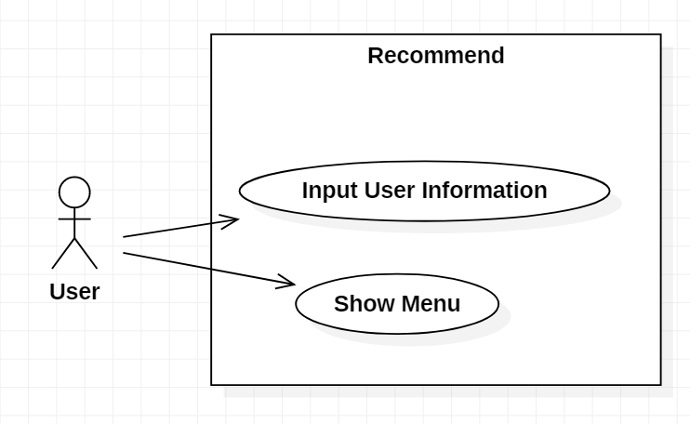

### **4.2 Detailed description of use cases**

#### **Case1: Input information and click 'recommendation'**

|  |  |  |  |
| --- | --- | --- | --- |
| Use Case | Case1: Input information and click ‘recommendation’ | | |
| Version | 1.0 | Created (date): | 2020/08/30 |
| Author | Sida Gao | | |
| Source | Users information | | |
| Goals | Input information and click ‘recommendation’ | | |
| Summary | Users input the information and click ‘recommendation’ to get the recommended diet | | |
| Actors | Users | | |
| Trigger | Users Input information and click ‘recommendation’ button. | | |
| Precondition | The user successfully input legitimate user information. | | |
| Frequency | Frequently | | |
| Post conditions | Network is available. | | |
| Diagram |  | | |

|  |  |  |
| --- | --- | --- |
| **Basic Flow** | *Actor* | *System* |
| 1. | User input user information |  |
| 2. | User click ‘recommendation’ button |  |
| 3. |  | Return recommended diet |

|  |  |  |
| --- | --- | --- |
| **Alternative Flow** | *Actor* | *System* |
| 1. |  | System shows "Fail to return recommended diet" |

#### **Case2: Show the menu recommended by system**

|  |  |  |  |
| --- | --- | --- | --- |
| Use Case | Case2: Show the menu recommended by system | | |
| Version | 1.0 | Created (date): | 2020/08/30 |
| Author | Guan Mingfei | | |
| Source | Algorithm | | |
| Goals | Show the user the menu recommended by system | | |
| Summary | Show the user the menu recommended by system | | |
| Actors | Users | | |
| Trigger | When server return the menu | | |
| Precondition | The User has clicked the recommend button | | |
| Frequency | Frequently | | |
| Post conditions | Network is available. | | |
| Diagram |  | | |

|  |  |  |
| --- | --- | --- |
| **Basic Flow** | *Actor* | *System* |
| 1. |  | Return recommended diet |
| 2. |  | Show menu page |
| 3. | Get the information |  |

|  |  |  |
| --- | --- | --- |
| **Alternative Flow** | *Actor* | *System* |
| 1. |  | Network error |

## **Internal Requirements**

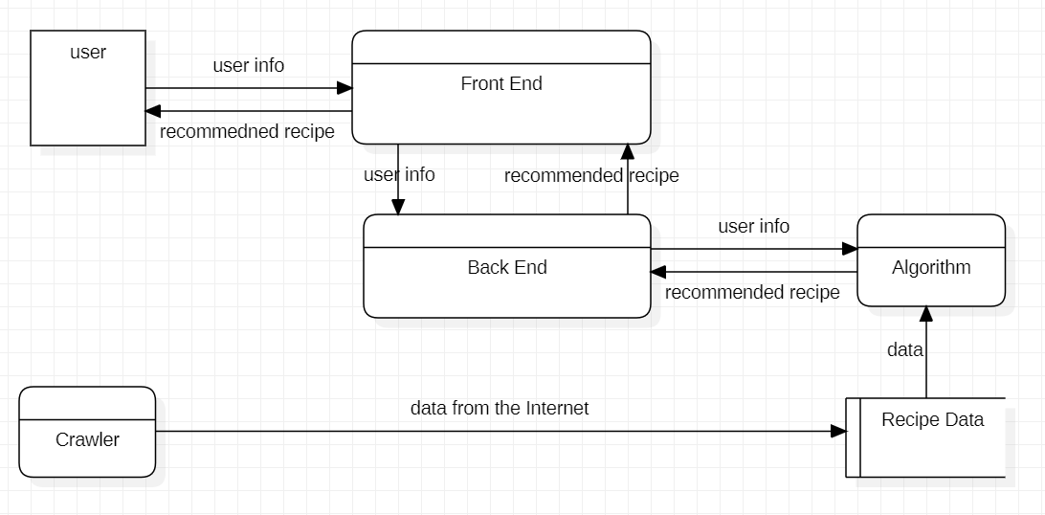

### **5.1 Module: Front End**

**Input（From the users)：**

1. **Name**
2. **Gender**
3. **Age**
4. **Height**
5. **Weight**
6. **Goal（Increasing Muscle/Losing Weight/Keeping in Shape)**
7. **Goal Weight**
8. **Action Style（Working/Studying/On Holiday)**

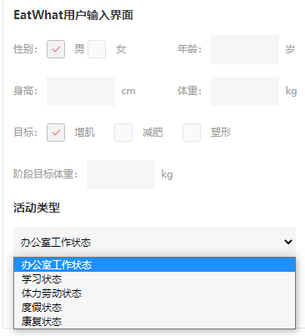

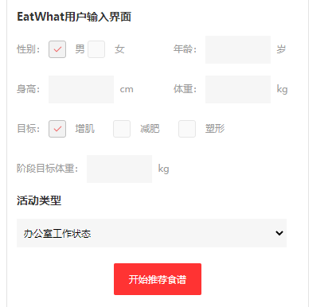

**Output：**

0) Choose Which Day of the Week

1) Breakfast

2) Lunch

3) Afternoon meal (optional)

4) Dinner

5) Evening meal (optional)

6) Recommend alternative meals

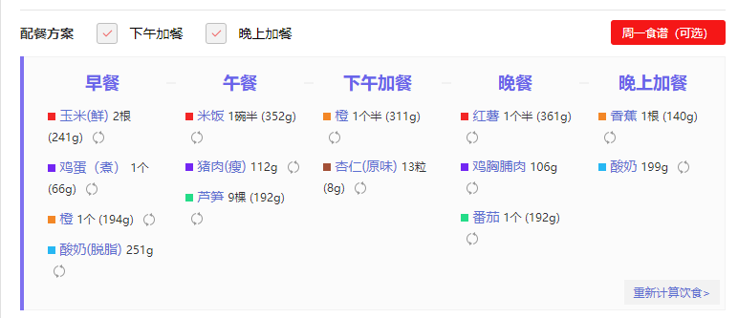

### 5.2 Module:Back-end

**#**It is **essential** for you to read this part, if you want to call ourinterfaces and get services

**API URL Address**

http://server:port/api_name

**#instance**

http://server:port/recommend

**Test Method**

curl -H 'content-type:application/json' -X POST -d 'JSON Input' http://server:port/api_name

#### 5.2.1 recommend

**Aim**:

1.        process request from front-end

2.        return the menu page with data

**Input Source: Form from HTML**

View Fucntion Input: The same as Algorithm

API Output: Rendered Menu HTML with data from algorithm

### 5.3 Algorithm

|  |  |  |  |  |
| --- | --- | --- | --- | --- |
| **Access**  **Method** | **Parameter**  **name** | **Parameter**  **type** | **Description** | **Output Type** |
| recommend | gender,age,height,weight,goal,goalWeight,activityIndex | int,int,float,float,int,float,float | Gender has two values, which are 0(male) or 1(female).  Goal has three values, which are 0(Increasing muscle), 1(losing weight), or 2(keeping in shape)  Goal Weight is the ideal weight you want.  For Increasing muscle,it must be greater than your present weight. For losing weight, it must be less than your present weight. For keeping in shape, this parameter is not useful because keeping in shape needs balanced diet with appropiate exercise, which doesn't need to lose your weight.  Activity Index has five values, which are 1.2,1.4,1.6,1.8,2.0. It is used to calculate your necessary calories according to your daily  activity. | A List of recipes of one week. Every element of this list is an instance of a class named OneDayDiet, which represents a recipe in one day. |

### 5.4 Database

Name:The name of the food.

Classification:Cereals, legumes, pasta, fruits, vegetables or dairy products.

Unit of measurement:The unit of measure and calories of food.

Heat:How many calories are there in this food per unit?

Protein:The content of protein in food, in grams.

Carbohydrate:The content of carbohydrate in food, in grams.

Fat:The content of fat in food, in grams.

Edible standard:Is it recommended for people who lose weight? Recommended, moderate or discreet?

### 5.5 Crawler

The crawler uses Python's request library and BeautifulSoup library. First I find some URL rules of the site, then go through these URL, to get the links in the page, and then get the key information in each page. This information includes classification, name, calorie, nutritional composition and so on.

Name:The name of the food.

Classification:Cereals, legumes, pasta, fruits, vegetables or dairy products.

Unit of measurement:The unit of measure and calories of food.

Heat:How many calories are there in this food per unit?

Protein:The content of protein in food, in grams.

Carbohydrate:The content of carbohydrate in food, in grams.

Fat:The content of fat in food, in grams.

Edible standard:Is it recommended for people who lose weight? Recommended, moderate or discreet?